JAIPURIA INSTITUTE OF MANAGEMENT, INDORE



EMPLOYEE ATTRITION ANALYSIS
A Data Analysis and Machine Learning Report
Dataset: IBM HR Analytics Attrition & Performance

SUBMITTED TO- SUBMITTED BY-
Dr. Manohar Kapse Shorya verma
JI25PG141

Table of Contents
1. Executive Summary
2. Introduction
3. Problem Statement
4. Objectives of the Study
5. Conceptual Understanding of the Problem
6. Dataset Description
7. Variables of the Study
8. Data Preparation and Cleaning
9. Descriptive Statistics
10. Frequency Distribution of Categorical Variables
11. Exploratory Data Analysis and Visual Understanding
12. Correlation Analysis
13. Machine Learning Methodology
14. Logistic Regression and Odds Ratios
15. Stepwise Logistic Regression
16. Decision Tree
17. Random Forest
18. Gradient Boosting
19. Model Comparison
20. Feature Importance
21. Key Insights
22. Managerial Implications
23. Limitations
24. ConclusioN
- Executive Summary
In hiring someone new and bring them up to speed, a company expends a great deal more than it does in maintaining the one it already has. This report examines 1,470 employees in a popular HR analytics dataset released by the data scientists at IBM and attempts to answer one simple question: who is going and can we tell?
About 16.1% of the employees in the data (237 out of 1,470) had left. When running descriptive statistics, charts and correlations and five different models, the same story emerged. Those that have gone long time without promotion, travel extensively, are single, have low job satisfaction and/or low involvement are much more likely to leave. Employees who have been with the company for a few years and are more experienced are more likely to remain with the older and more senior manager. The top risk roles include Sales Representatives, Laboratory Technicians and HR.
The most successful modelling was stepwise logistic regression (AUC 0.83); gradient boosting (AUC 0.81) was the next. They are all incomplete, however: With one leaver out of six, only a minority of those who do go catch them, as is discussed as a limitation.
- Introduction
Employee turnover is a steady and gradual decrease in staff numbers. Some of it is good but when good people are coming and going quicker than they can be replaced, there are costs, the recruitment costs, the training costs, the lost knowledge and the morale costs of those people who are still here. Until now, HR departments have been responding to the resignation letter.
The concept of HR analytics is to identify the red flags in advance, with the data a business already has about its employees. In this project I take the role of an HR analyst. I write Python code to analyze a data set that contains employees records; I perform descriptions of the workforce; I test for correlation between variables and attrition; and I then develop predictive models. All claims in the report are linked to a table and/or a chart.
- Problem Statement
Domain of the Study
Human Resource Management, HR analytics, employee retention (including with reference to organisational behaviour).
Broad Problem Statement
A company cannot predict in advance who of their workers will be resigning. If there is no signal, retention effort is distributed over everyone or done after the individual has made up their mind to go. The problem that is addressed in this study is: What are the personal, job-related and satisfaction-related variables that are associated with employees who quit, and how effective is a machine learning model to predict which employees are likely to leave?
- The objectives of the study are:
- Using descriptive statistics, describe the profile of the workforce on the scale variables and the frequency tables for the categorical variables.
- Compare attrition rates by overtime, business trip, marital status, department, job role and satisfaction level.
- Test the strength and direction of a linear association between numeric variables and attrition.
- Use odds ratios to describe the effect of each factor on the risk of leaving, fitted using logistic regression.
- To obtain a smaller list of statistically significant factors, use stepwise (backward elimination) logistic regression.
- Construct and compare a decision tree, a random forest model and a gradient boosting model with the logistic regression models.
- Determine the most critical factors and make them actionable retention suggestions.

- Conceptual Understanding of Problem
There are seldom singular reasons for people to leave. Research on organizational behaviour typically categorizes the reasons into three families, and the data set also has variables for all three categories:
- Overtime, business travel, distance from home, job role and job level are all job & workload factors. These are used to indicate the level of difficulty of the work.
- Reward and growth factors: Monthly income, salary increase, stock options, Training, and years since last promotion. These refer to the sense of reward and progress the employee has.
- Satisfaction and relationship factors: Job satisfaction, environment satisfaction, work-life balance, job involvement, relationship satisfaction and years with the current manager. These represent the employee's attitude towards the job.
Along with these are the personal factors – age, marital status and total work experience – that cannot be altered by a manager, but can be useful in determining who is most likely to be mobile. When evaluating a good analysis, one must therefore analyse each family individually and then collectively, and it is this approach that is adopted in the sections below.
Attrition is a binary classification problem (yes/no) that is recorded. There are only 6/10 employees who leave so classes are imbalanced and it makes a difference when judging models: If a model predicts ‘stays’ for all employees it would be 84% correct but not useful. Recall, precision and AUC are therefore reported next to accuracy.
- Dataset Description
This data set is the IBM HR Analytics Employee Attrition & Performance data set. Developed by IBM data scientists as a realistic but fictional HR data set for teaching purposes. It includes 1470 employee records and 35 columns that include employee demographics, job information, pay, employee satisfaction, and attrition outcome. The copy used here has been downloaded from a public GitHub mirror of the Kaggle data set; the link to the data set is provided in Section 25. This is not the data set provided in the group assignment—it is a new one and is different in the domain (HR domain, not finance or marketing).
- Variables of the Study
Four columns were dropped before analysis: EmployeeCount, Over18 and StandardHours (all have the same value, and therefore provide no information), and EmployeeNumber (it's a simple ID). The other 31 columns are classified below. The 1 to 5 rating columns are treated as ordinal since there is not a guarantee that the intervals between the ratings are the same.
S.No | Variable Name | Type of Variable
1 | Age | Scale (numeric)
2 | DailyRate | Scale (numeric)
3 | DistanceFromHome | Scale (numeric)
4 | HourlyRate | Scale (numeric)
5 | MonthlyIncome | Scale (numeric)
6 | MonthlyRate | Scale (numeric)
7 | NumCompaniesWorked | Scale (numeric)
8 | PercentSalaryHike | Scale (numeric)
9 | TotalWorkingYears | Scale (numeric)
10 | TrainingTimesLastYear | Scale (numeric)
11 | YearsAtCompany | Scale (numeric)
12 | YearsInCurrentRole | Scale (numeric)
13 | YearsSinceLastPromotion | Scale (numeric)
14 | YearsWithCurrManager | Scale (numeric)
15 | Education | Ordinal (coded 1 to 4/5)
16 | EnvironmentSatisfaction | Ordinal (coded 1 to 4/5)
17 | JobInvolvement | Ordinal (coded 1 to 4/5)
18 | JobLevel | Ordinal (coded 1 to 4/5)
19 | JobSatisfaction | Ordinal (coded 1 to 4/5)
20 | PerformanceRating | Ordinal (coded 1 to 4/5)
21 | RelationshipSatisfaction | Ordinal (coded 1 to 4/5)
22 | StockOptionLevel | Ordinal (coded 0 to 3)
23 | WorkLifeBalance | Ordinal (coded 1 to 4/5)
24 | BusinessTravel | Nominal (categorical)
25 | Department | Nominal (categorical)
26 | EducationField | Nominal (categorical)
27 | Gender | Nominal (categorical)
28 | JobRole | Nominal (categorical)
29 | MaritalStatus | Nominal (categorical)
30 | OverTime | Nominal (categorical)
31 | Attrition (target) | Binary / Nominal (Yes = left, No = stayed)

- Data Preparation and Cleaning
- Reviewed all 35 columns to ensure there are no missing data: No missing data found.
- There were no duplicate rows that were found. EmployeeCount, Over18, StandardHours (constant columns) and EmployeeNumber (identifier).
- Set up a 0/1 target: Attr (1 = employee left, 0 = employee remained).
- Nominal variables were one-hot encoded for modelling with the first category omitted.
- The department variable was not included in the models because the variable Job Role already nests it (all members of the Job role of Sales are in the department of Sales and all members of the Job role of Research Scientist are in the department of R&D), thus the two sets of dummy variables were collinear and the first model produced an unstable fit.
- The logistic regressions were done on standardised variables (StandardScaler). The statsmodels models used original units, thus their odds ratios are per one unit.
- Data was divided 80/20, stratified with 1176 employees in the training set and 294 in the test set, with approximately 16% attrition in both sets.

- Descriptive Statistics
The following descriptive statistics are for the 14 scale-level variables. If skewness is greater than approximately +/-1 then the distribution is highly skewed.
Variable | Mean | Std. Dev. | Min | 25% | Median | 75% | Max | Skew
Age | 36.92 | 9.14 | 18.0 | 30.0 | 36.0 | 43.0 | 60.0 | 0.41
DailyRate | 802.49 | 403.51 | 102.0 | 465.0 | 802.0 | 1157.0 | 1499.0 | -0.0
DistanceFromHome | 9.19 | 8.11 | 1.0 | 2.0 | 7.0 | 14.0 | 29.0 | 0.96
HourlyRate | 65.89 | 20.33 | 30.0 | 48.0 | 66.0 | 83.75 | 100.0 | -0.03
MonthlyIncome | 6502.93 | 4707.96 | 1009.0 | 2911.0 | 4919.0 | 8379.0 | 19999.0 | 1.37
MonthlyRate | 14313.1 | 7117.79 | 2094.0 | 8047.0 | 14235.5 | 20461.5 | 26999.0 | 0.02
NumCompaniesWorked | 2.69 | 2.5 | 0.0 | 1.0 | 2.0 | 4.0 | 9.0 | 1.03
PercentSalaryHike | 15.21 | 3.66 | 11.0 | 12.0 | 14.0 | 18.0 | 25.0 | 0.82
TotalWorkingYears | 11.28 | 7.78 | 0.0 | 6.0 | 10.0 | 15.0 | 40.0 | 1.12
TrainingTimesLastYear | 2.8 | 1.29 | 0.0 | 2.0 | 3.0 | 3.0 | 6.0 | 0.55
YearsAtCompany | 7.01 | 6.13 | 0.0 | 3.0 | 5.0 | 9.0 | 40.0 | 1.76
YearsInCurrentRole | 4.23 | 3.62 | 0.0 | 2.0 | 3.0 | 7.0 | 18.0 | 0.92
YearsSinceLastPromotion | 2.19 | 3.22 | 0.0 | 0.0 | 1.0 | 3.0 | 15.0 | 1.98
YearsWithCurrManager | 4.12 | 3.57 | 0.0 | 2.0 | 3.0 | 7.0 | 17.0 | 0.83

Variable-by-Variable Explanation
- Age range from 18 to 60 with a mean of 36.9 and a median age of 36, the workforce is predominantly in their 30s and early 40s. The skewness is relatively low (+0.41) indicating that the distribution is close to symmetric with a small tail of older employees.
- The monthly income data is skewed to the right and the mean is significantly higher than the median. (6503>4919 and the skewness is +1.37) A significant number of employees have a salary between 2,900 and 8,400 and a small number of senior employees have wages up to 19,999, which causes the mean to be pulled up. For this reason the median is the fairer measure of a 'typical' salary here.
- All three of these (DailyRate, HourlyRate and MonthlyRate) have skewness near zero and appear to be nearly even across their range (for instance, DailyRate spans from 102 to 1,499, with a mean rate of 802). They are not correlated with MonthlyIncome in a steady manner, suggesting that they are fabricated fields and not very reliable as indicators of real pay.
- DistanceFromHome: has a range of 1 to 29, a median of 7, and a mean of 9.2 (+0.96 skew). The majority of people work quite near to their homes, with a tail of employees commuting 20 units or more. The median for
- NumCompaniesWorked was 2 and the mean was 2.7 with some having worked for up to 9 employers (skew +1.03). The majority of employees are on first or second employer and a minority are employees with many jobs. •
- PercentSalaryHike: between 11% and 25% with a mean of 15.2%. No one in the data received a really small raise, as it is the lowest increase, which is 11%.
- TotalWorkingYears: mean 11.3, median 10, maximum 40 (skew +1.12). The majority of the staff have 10 years experience or less with a handful of staff veterans.
- The mean number of training times last year was 2.8 sessions with almost all participants between 2 and 3 sessions and with a range of 0 to 6.
- The years at company variable shows the mean of 7.0, median of 5, and has the highest right skew (+1.76) among the tenure variables, and a maximum of 40.
- The company has a long tail of long tenured employees and a long head of younger employees.
- Both 'YearsInCurrentRole' and ' YearsWithCurrManager' have median values of 3 and means around 4, suggesting that majority have only been in their current role and manager for a few years.
- The median is 1 year, the 25th percentile is 0, but the maximum value is 15, and the skewness value is +1.98, the largest in the data. A number of employees were promoted in the past weeks and some have been waiting an extremely long time.
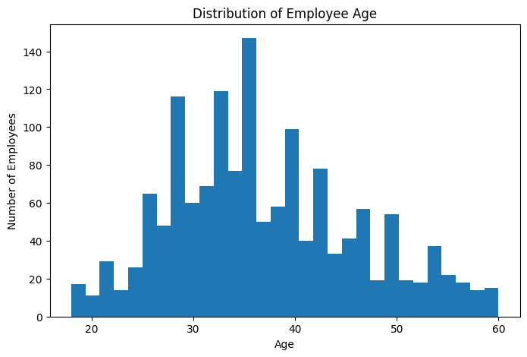

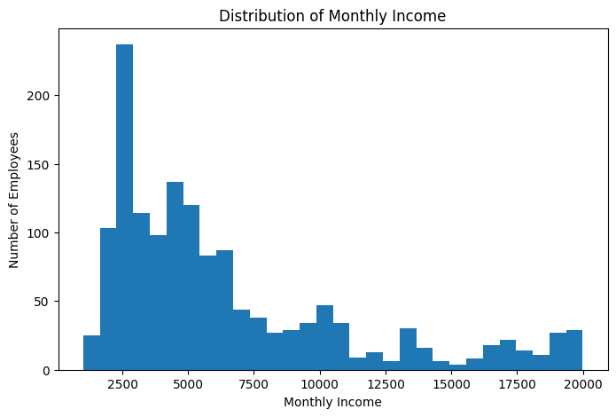

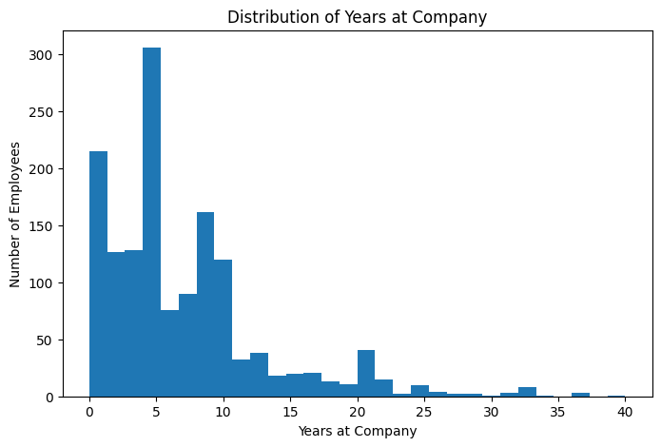

- Frequency Distribution of Categorical Variables.
The number of employees in each category and the percentage of employees leaving that category is represented in each table below.
BusinessTravel | Count | Percent | Attrition rate (%)
Travel_Rarely | 1043 | 71.0% | 15.0
Travel_Frequently | 277 | 18.8% | 24.9
Non-Travel | 150 | 10.2% | 8.0

Department | Count | Percent | Attrition rate (%)
Research & Development | 961 | 65.4% | 13.8
Sales | 446 | 30.3% | 20.6
Human Resources | 63 | 4.3% | 19.0

Gender | Count | Percent | Attrition rate (%)
Male | 882 | 60.0% | 17.0
Female | 588 | 40.0% | 14.8

MaritalStatus | Count | Percent | Attrition rate (%)
Married | 673 | 45.8% | 12.5
Single | 470 | 32.0% | 25.5
Divorced | 327 | 22.2% | 10.1

OverTime | Count | Percent | Attrition rate (%)
No | 1054 | 71.7% | 10.4
Yes | 416 | 28.3% | 30.5

JobRole | Count | Percent | Attrition rate (%)
Sales Executive | 326 | 22.2% | 17.5
Research Scientist | 292 | 19.9% | 16.1
Laboratory Technician | 259 | 17.6% | 23.9
Manufacturing Director | 145 | 9.9% | 6.9
Healthcare Representative | 131 | 8.9% | 6.9
Manager | 102 | 6.9% | 4.9
Sales Representative | 83 | 5.6% | 39.8
Research Director | 80 | 5.4% | 2.5
Human Resources | 52 | 3.5% | 23.1

Attrition | Count | Percent
No (stayed) | 1233 | 83.9%
Yes (left) | 237 | 16.1%

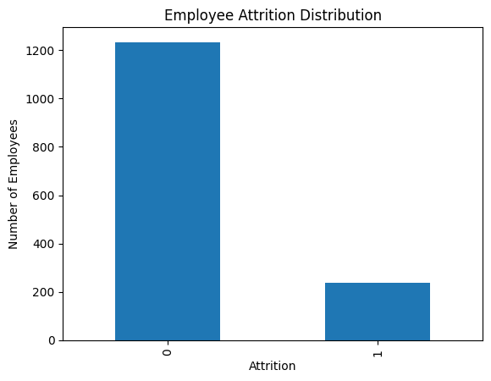
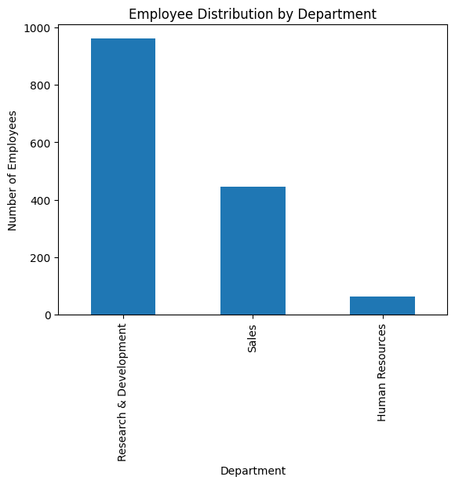

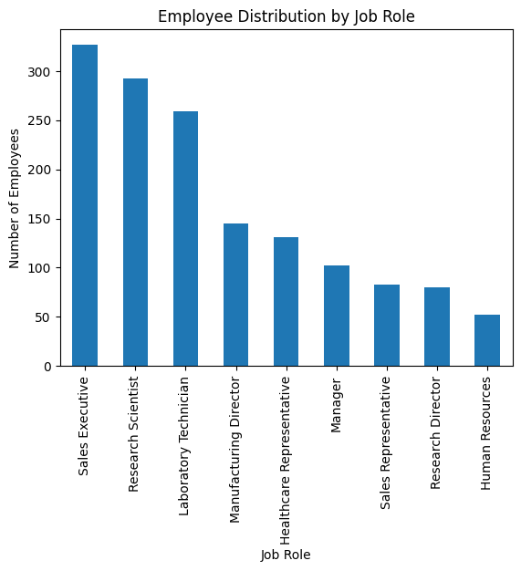

Interpretation
- Attrition: 237 of 1,470 employees (16.1%) left. There is an imbalance in the data, approximately 5 to 1, and that's why accuracy is the wrong score later on.
- Overtime: 28.3% of employees (416) work overtime. They have a 30.5% attrition rate compared with 10.4% of those who do not, about three times as high. It is the most information-rich categorical signal in the data. Most employees (71%) travel infrequently for business. Attrition increases incrementally from 8.0% (non-travellers), 15.0% (rare travellers) and 24.9% (frequent travellers).
- Marital status: 32% of employees are single, with about double the number of employees leaving due to marital status compared to married (25.5%) and divorced (10.1%).
- Department and job role: R&D is 2/3 of the company, and 13.8% of employees in this department are leaving their job; in Sales, 20.6% of employees are leaving their job. The job role view appears clearer: Sales Representatives have a 39.8% leaving rate; Laboratory Technicians a 23.9% leaving rate; HR staff a 23.1% leaving rate, with a very low leaving rate for Research Directors (2.5%) and Managers (4.9%). It is as important to have seniority as it is to have function.
- Gender: 60% male and 40% female. Women leave at 14.8% and men at 17.0%, a small gap.

- Exploratory Data Analysis And Visual Understanding

Attrition by overtime
The overtime bar is about three times taller than the no-overtime bar (30.5% vs 10.4%). Extra hours does not only correlate with leaving it is the greatest difference between any two groups in the data set. There were 416 people who worked overtime, but 127 of them left.
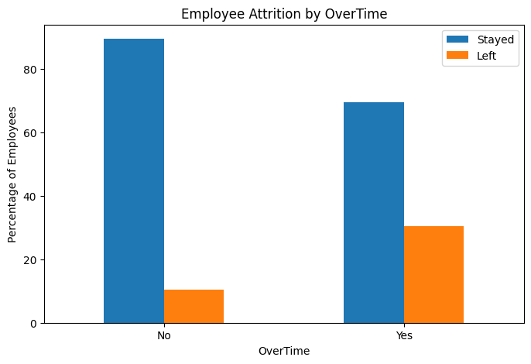
Attrition by business travel and marital status
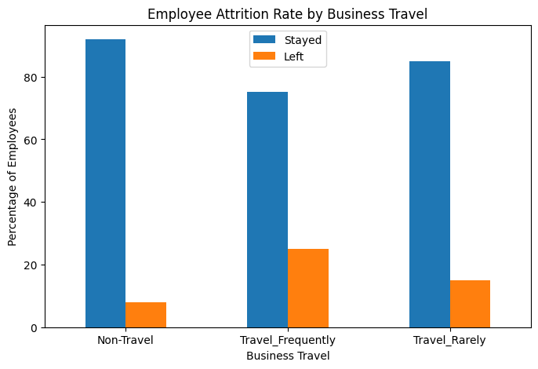
There is a definite trend in both charts. Three times as many frequent travellers leave as non-travellers and twice as many single employees as married employees leave. Taking a guess at it, I think that those who don't have as many family connections or those who spend more time traveling find it easier or more tempting to move on.
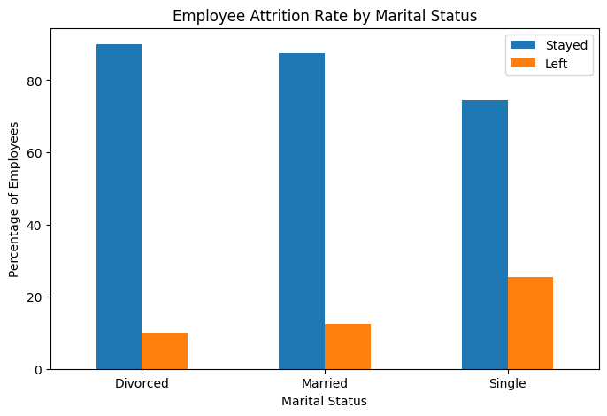
Attrition by Job Role
The impact of attrition by job role. (The rates in the Section 10 table are the rates by role.) The range of roles is extremely large, ranging from 2.5% (Research Director) to 39.8% (Sales Representative). The bottom tier of entry-level positions includes Sales Representatives, Laboratory Technicians and HR staff. Directors and Managers are near the bottom. In this suggests stage of the career and pressure of role are important drivers.

Numeric variable by attrition status
The box plots convey a consistent message. The average age of employees who quit was 33.6 years compared to 37.6 years for those who stayed, the average monthly income was $4,787 compared to $6,833 and the average distance from the company was 10.6 miles vs 8.9 miles. The income range of people who leave is quite narrow and lower, so it is primarily lower paid workers who leave.
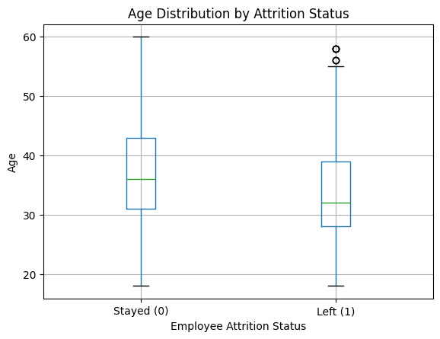
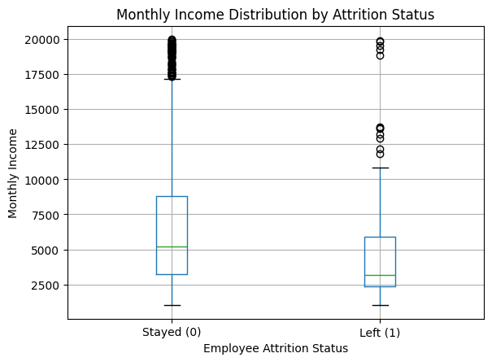
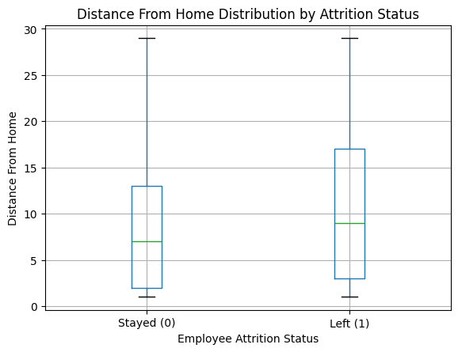
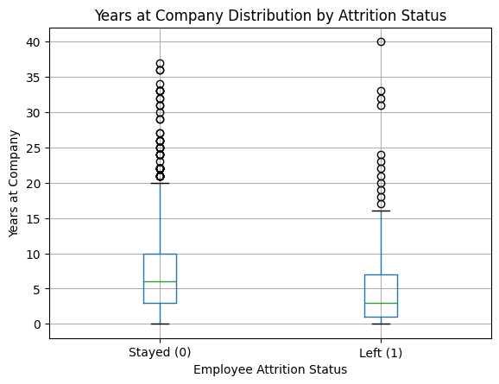
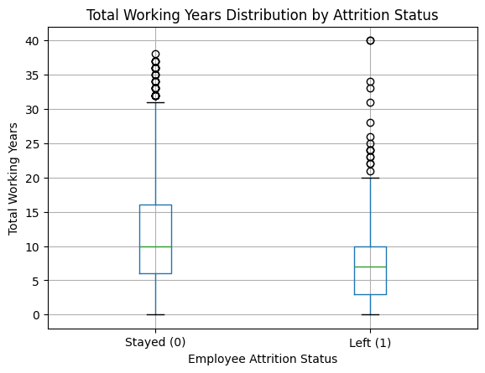
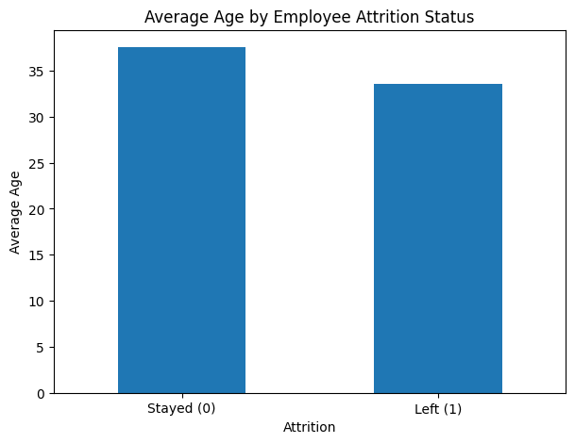
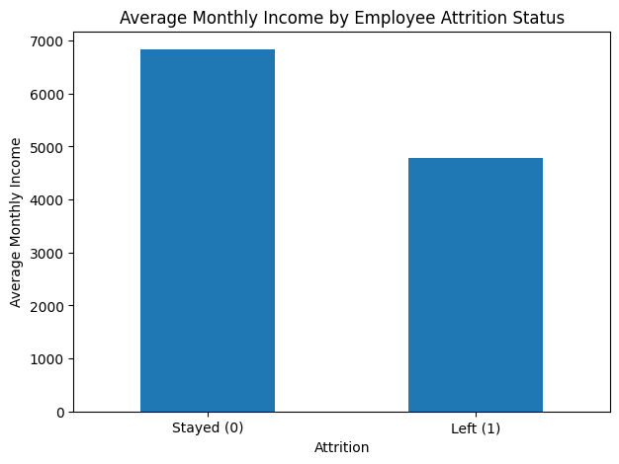
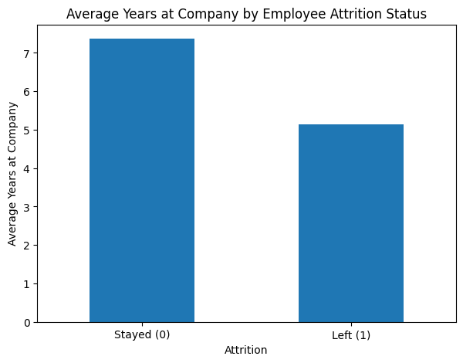
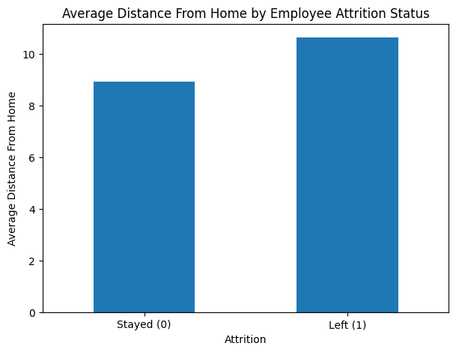
- Correlation Analysis
Attainment (0/1) was correlated with all numeric and ordinal variables using Pearson correlation. They are point-biserial correlations and only measure linear association as the target is binary.
All of the correlations are small, with the highest being the -0.17 correlation between TotalWorkingYears and Attrition; none of the numeric values alone predicts attrition. The most negative associations are with TotalWorkingYears, JobLevel, YearsInCurrentRole, MonthlyIncome and Age: the more senior, experienced and higher-paid employees are, the less they will stay. The only positive links of any consequence are that of DistanceFromHome (+0.08) and NumCompaniesWorked (+0.04).
Variable | Correlation with Attrition
TotalWorkingYears | -0.171
JobLevel | -0.169
YearsInCurrentRole | -0.161
MonthlyIncome | -0.16
Age | -0.159
YearsWithCurrManager | -0.156
StockOptionLevel | -0.137
YearsAtCompany | -0.134
JobInvolvement | -0.13
JobSatisfaction | -0.103

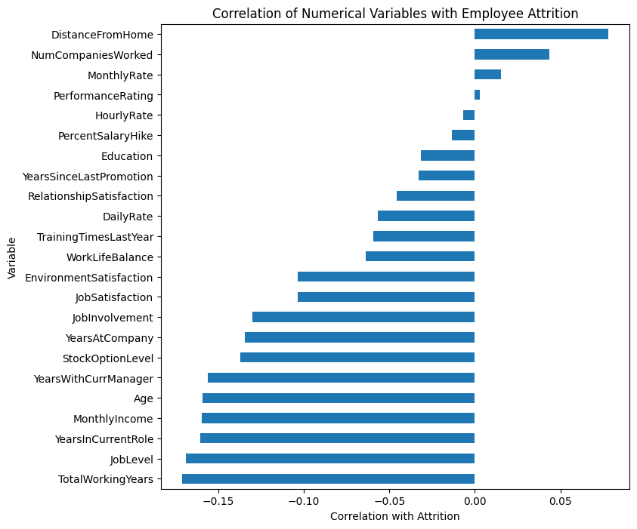
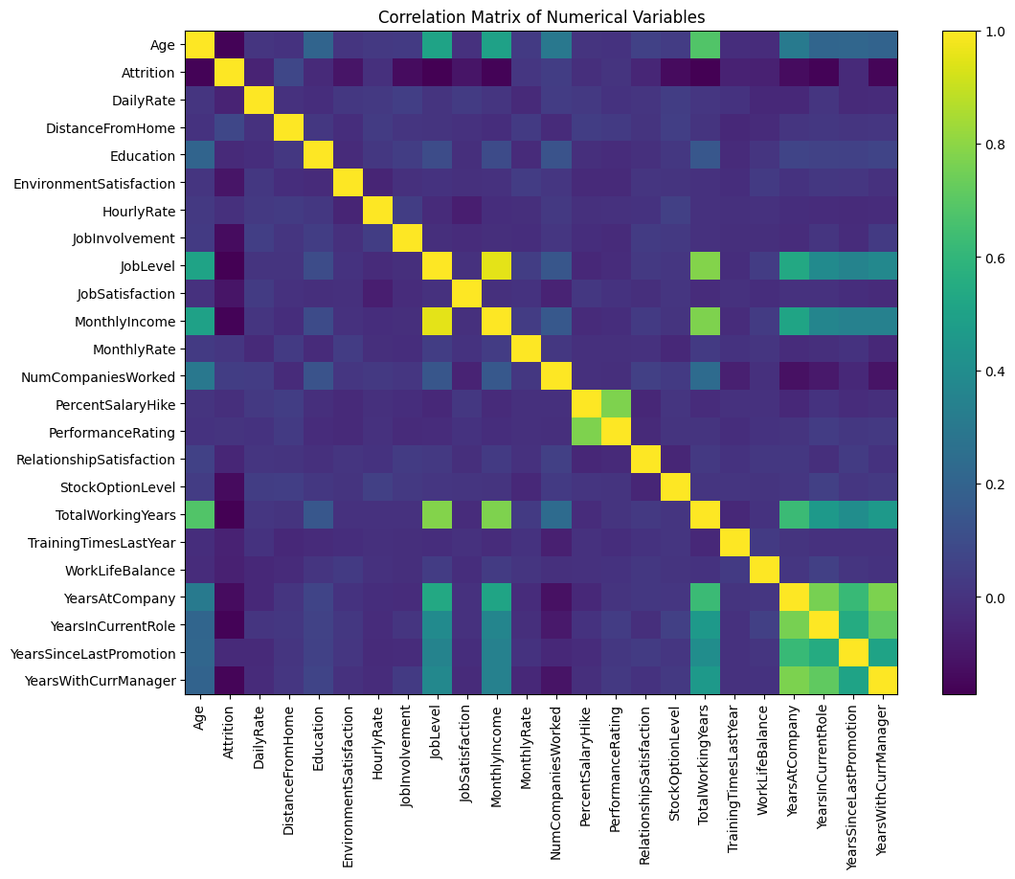
There are also a significant number of very high correlations among the experience variables (Age, TotalWorkingYears, YearsAtCompany, YearsInCurrentRole, YearsWithCurrManager) and between JobLevel and MonthlyIncome (approximately 0.95). The overlap in these variables means that the logistic regression selects some of these variables and that the individual coefficients within these variables should be interpreted carefully.
- Machine Learning Methodology
Five models were trained to predict attrition: a logistic regression using all predictors, a stepwise (backward elimination) logistic regression, a decision tree (maximum depth 5), a random forest (200 trees, balanced class weights) and a gradient boosting classifier (200 trees, learning rate 0.05, depth 3). After one-hot encoding there were 42 predictor columns. All models were trained on the 80% training set (1176 employees) and evaluated on the withheld 20% test set (294 employees) via the metrics: accuracy, precision, recall, F1 score and ROC-AUC.
Recall and AUC (how often the model identifies the real leavers and how well the model ranks leavers over stayers) are more important than accuracy here since the purpose is to find leavers.
- Logistic regression and odds ratios
All 42 predictors were used to fit a logistic regression in statsmodels in order to obtain coefficients, p-values and confidence intervals. The pseudo R-squared is 0.337, a good fit for a behavioural data set. Odds ratios are for each additional unit: each additional year of age, each rating point, each additional company worked for, etc. The odds ratio for the dummy variables is the comparison between the category and the reference category (Healthcare Representative for job role, Divorced for marital status, Non-Travel for business travel, Female for gender).
Predictor | Odds Ratio | 95% CI | P-value
OverTime_Yes | 7.28 | 4.98 - 10.64 | <0.001
JobRole_Sales Representative | 7.19 | 2.44 - 21.19 | <0.001
BusinessTravel_Travel_Frequently | 6.72 | 2.99 - 15.07 | <0.001
JobRole_Laboratory Technician | 4.38 | 1.70 - 11.29 | 0.002
MaritalStatus_Single | 3.12 | 1.58 - 6.13 | 0.001
JobRole_Sales Executive | 2.78 | 1.16 - 6.69 | 0.022
BusinessTravel_Travel_Rarely | 2.78 | 1.32 - 5.85 | 0.007
Gender_Male | 1.48 | 1.03 - 2.13 | 0.033
NumCompaniesWorked | 1.22 | 1.13 - 1.31 | <0.001
YearsSinceLastPromotion | 1.19 | 1.10 - 1.29 | <0.001
YearsAtCompany | 1.09 | 1.01 - 1.18 | 0.019
DistanceFromHome | 1.05 | 1.02 - 1.07 | <0.001
Age | 0.97 | 0.94 - 1.00 | 0.022
TotalWorkingYears | 0.94 | 0.89 - 1.00 | 0.037
YearsWithCurrManager | 0.88 | 0.80 - 0.96 | 0.005
YearsInCurrentRole | 0.86 | 0.79 - 0.94 | 0.001
TrainingTimesLastYear | 0.83 | 0.72 - 0.96 | 0.010
RelationshipSatisfaction | 0.77 | 0.66 - 0.91 | 0.002
WorkLifeBalance | 0.69 | 0.54 - 0.88 | 0.003
JobSatisfaction | 0.66 | 0.56 - 0.78 | <0.001
EnvironmentSatisfaction | 0.65 | 0.55 - 0.76 | <0.001
JobInvolvement | 0.59 | 0.46 - 0.75 | <0.001

Reading the Odds Ratios
- If all factors are the same, workers who work overtime have approximately seven times the chance of turnover (OR about 7). It is one of the most potent of these effects within the model.
- People who travel for business have about 6.7 times the odds of leaving than those who never travel at all, and rare business travellers about 2.8 times the odds.
- The confidence interval is large as the non-travel group is small (n = 150 employees), but the indication is definite. Highlighting the above, Sales Representatives (OR about 7.2); Laboratory Technicians (about 4.4); and Sales Executives (about 2.8) are among the more prominent job roles.
- The role is a strong predictor of the risk, regardless of satisfaction and experience. The odds of leaving are approximately 3.1 times higher for single employees than for divorced employees.
- Gender: men are 1.5 times more likely to leave than women, controlling for other factors. This is a small effect but is statistically significant; this is different from the raw rates (17.0% v 14.8%).
- Protective factors (OR below 1): JobInvolvement (about 0.59 per rating point), EnvironmentSatisfaction (0.65), JobSatisfaction (0.66), WorkLifeBalance (0.69) and RelationshipSatisfaction (0.77). Every 1-point increment in these ratings reduces the likelihood of leaving by 25-40%.
- The risk factors for the unit of company show a 22% increase in risk for every additional company worked for (OR 1.22); the risk factors for the unit of time since last promotion show a 19% increase in risk for every additional year between promotions (OR 1.19); and the risk factors for the unit of distance from home show a 5% increase in risk for each additional unit of distance from home (OR 1.05). However, the odds ratio of age (OR 0.97 per year), TotalWorkingYears (OR 0.94), YearsInCurrentRole (OR 0.86) and YearsWithCurrManager (OR 0.88) are all below 1, indicating that the more these employees are older, more experienced, and have a stable role and manager, the more likely they are to remain.
- Monthly income, job level, education, performance rating, stock option level and percent salary hike are not significant. This does not mean to say that income is unimportant, because job level and age and experience (job level and income correlate at ~0.95) are interwoven and it is difficult to separate the effects of these variables.
- Stepwise Logistic Regression
The full model was used as the starting point, and the predictor with the largest p-value was eliminated one by one until only predictors with a 5% significant level remained. 18 predictors were removed (the first ones to go were Education, MonthlyIncome, EducationField_Marketing and HourlyRate) and 24 remained. The pseudo R-squared value of the stepwise model is very close to the full model, with 0.325 compared to the 0.337 in the full model, and therefore little was lost by removing the additional variables.
Predictor | Odds Ratio | 95% CI | P-value
OverTime_Yes | 7.21 | 4.96 - 10.48 | <0.001
BusinessTravel_Travel_Frequently | 6.86 | 3.12 - 15.06 | <0.001
JobRole_Sales Representative | 5.46 | 2.85 - 10.44 | <0.001
JobRole_Human Resources | 3.65 | 1.58 - 8.39 | 0.002
MaritalStatus_Single | 3.19 | 2.23 - 4.57 | <0.001
JobRole_Laboratory Technician | 3.03 | 1.90 - 4.83 | <0.001
BusinessTravel_Travel_Rarely | 2.86 | 1.38 - 5.91 | 0.005
EducationField_Technical Degree | 2.44 | 1.41 - 4.22 | 0.001
JobRole_Sales Executive | 2.37 | 1.51 - 3.73 | <0.001
Gender_Male | 1.47 | 1.03 - 2.10 | 0.034
NumCompaniesWorked | 1.21 | 1.12 - 1.30 | <0.001
YearsSinceLastPromotion | 1.19 | 1.10 - 1.29 | <0.001
YearsAtCompany | 1.09 | 1.01 - 1.17 | 0.025
DistanceFromHome | 1.04 | 1.02 - 1.07 | <0.001
Age | 0.97 | 0.95 - 1.00 | 0.024
TotalWorkingYears | 0.92 | 0.88 - 0.97 | 0.001
YearsWithCurrManager | 0.88 | 0.80 - 0.96 | 0.004
YearsInCurrentRole | 0.88 | 0.80 - 0.95 | 0.003
TrainingTimesLastYear | 0.82 | 0.71 - 0.94 | 0.005
RelationshipSatisfaction | 0.78 | 0.66 - 0.91 | 0.002
WorkLifeBalance | 0.68 | 0.53 - 0.86 | 0.002
JobSatisfaction | 0.65 | 0.56 - 0.77 | <0.001
EnvironmentSatisfaction | 0.65 | 0.55 - 0.76 | <0.001
JobInvolvement | 0.59 | 0.47 - 0.75 | <0.001

To read the Odds Ratios. Everything else being equal, those who work overtime are about 7 times more likely to quit. (OverTime = Yes) It is a very powerful effect in the model. The odds of leaving are approximately 6.7 times higher for business travellers who frequently travel than for those who never travel, and approximately 2.8 times higher for business travellers who rarely travel than for those who never travel. The direction is clear as the number of employees who do not travel is small (150 employees) and the confidence intervals are wide. Job roles which stand out are Sales Representatives (OR about 7.2), Laboratory Technicians (about 4.4) and Sales Executives (about 2.8). Even when accounting for satisfaction and experience, Role is a strong indicator of risk level. Marital status - the divorce rate is roughly 3.1 times greater for single employees than for divorced employees. Other factors being equal, men are about 1.5 times more likely to leave compared to women. This is a low level effect, but statistically significant, not exactly the same as the raw rates (17.0% versus 14.8%). Protective factors (OR below 1): JobInvolvement (about 0.59 per rating point), EnvironmentSatisfaction (0.65), JobSatisfaction (0.66), WorkLifeBalance (0.69) and RelationshipSatisfaction (0.77). Every point for these ratings reduces the likelihood of a student leaving by approximately 25-40%.
- Decision Tree
A tree of depth 5 was used to ensure that the model is easily explained and not merely memorising the training data. The accuracy value (0.83) seems to be good, but it is, on the whole, because most of the employees remain: the recall value is only (0.17) and the ROC-AUC is the lowest of the 5 models (0.66). This problem is too coarse-grained to be solved with a single tree.
Metric | Value
Accuracy | 0.8333
Precision | 0.4444
Recall | 0.1702
F1 | 0.2462
AUC | 0.6594

- Random Forest
Metric | Value
Accuracy | 0.8435
Precision | 0.5714
Recall | 0.0851
F1 | 0.1481
AUC | 0.7733

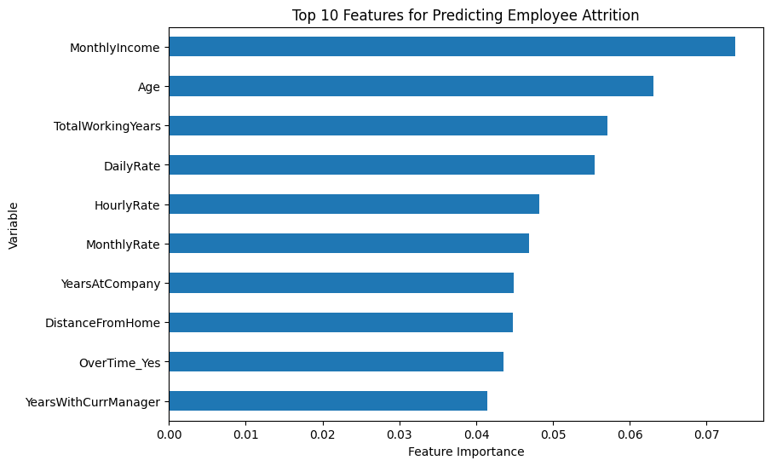
I found that the random forest (with an average number of trees of 200) improved the AUC to 0.77, much better than the single tree, and ranks employees by risk much better. It is, however, very cautious at the default cut-off of 0.5, with a recall of only 0.09, meaning that it can miss many genuine leavers (precision 0.57, with the ones it does flag right more than half the time).
- Gradient boosting
It is a process in which the trees are added sequentially, with the tree for each iteration fixing the errors of the previous tree. It has the highest AUC value among the three tree-based models as 0.812, while the accuracy and precision are 0.847 and 0.56 respectively. It also has a low recall at the default threshold (0.19), similar to the random forest.
Metric | Value
Accuracy | 0.8469
Precision | 0.5625
Recall | 0.1915
F1 | 0.2857
AUC | 0.8116

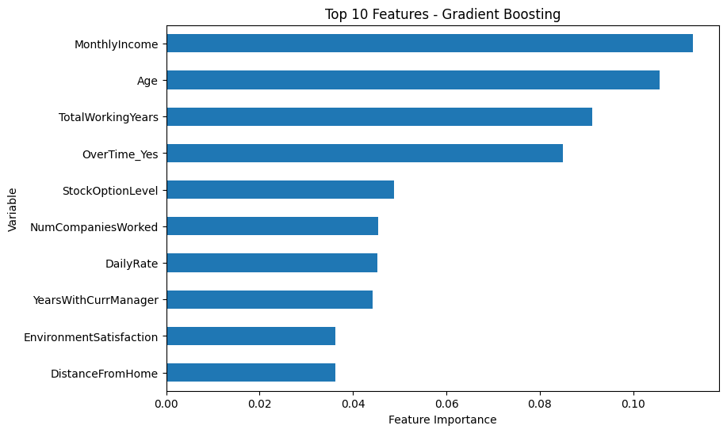
- Model Comparsion

Model | Accuracy | Precision | Recall | F1 | AUC
Logistic Regression | 0.861 | 0.615 | 0.340 | 0.438 | 0.808
Stepwise Logistic Regression | 0.861 | 0.607 | 0.362 | 0.453 | 0.832
Decision Tree | 0.833 | 0.444 | 0.170 | 0.246 | 0.659
Random Forest | 0.844 | 0.571 | 0.085 | 0.148 | 0.773
Gradient Boosting | 0.847 | 0.562 | 0.192 | 0.286 | 0.812

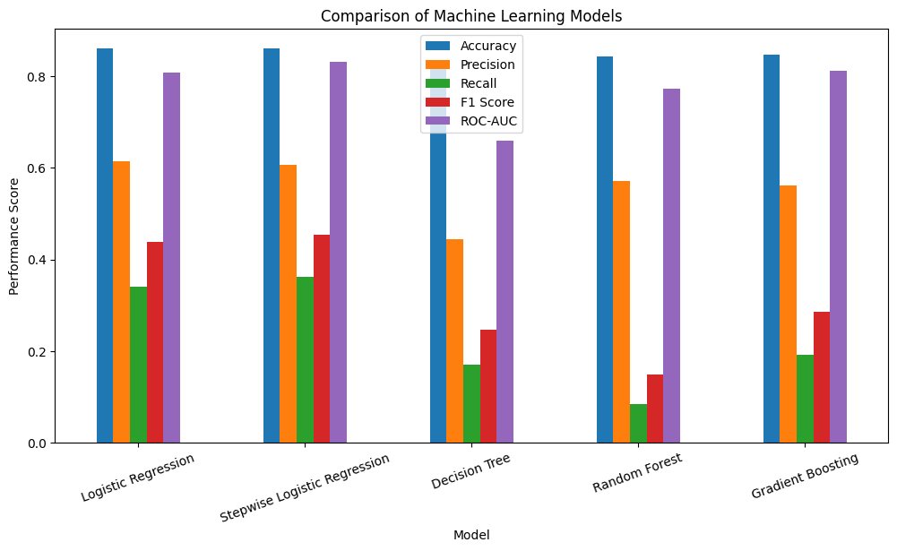
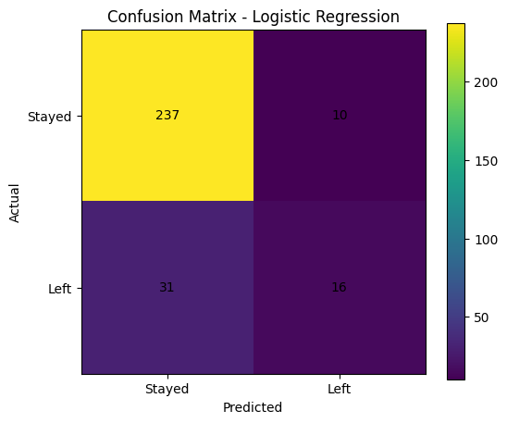
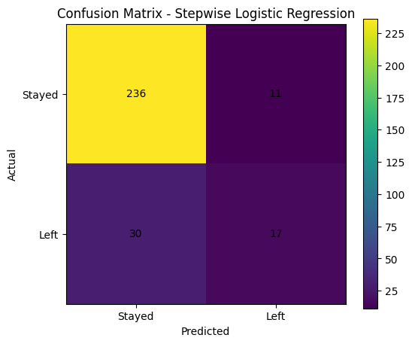
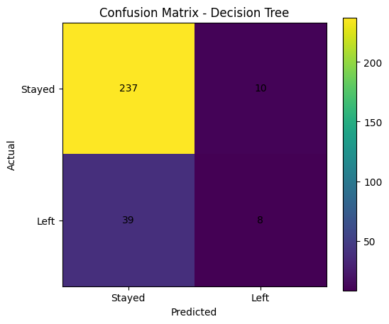
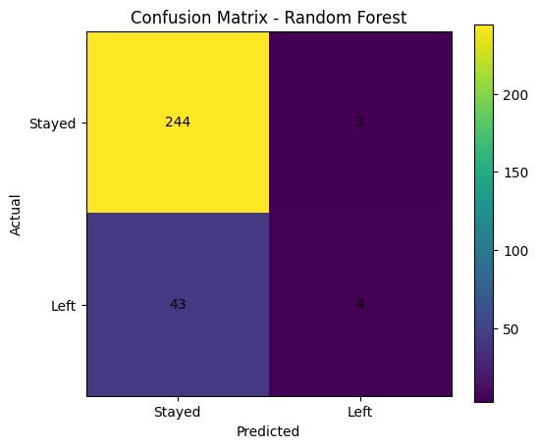
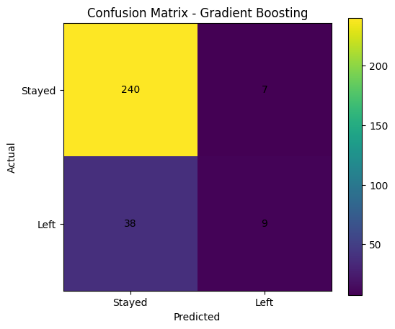

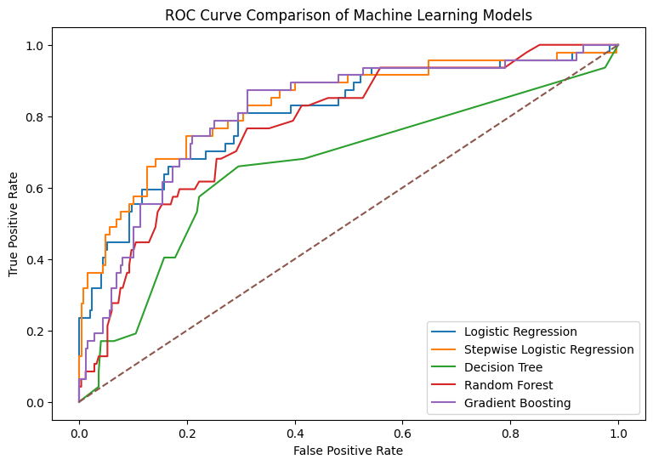
The stepwise logistic regression model is the best model in terms of ROC-AUC (0.832) and F1 score (0.453) and the highest recall (0.362). It is followed by gradient boosting (AUC 0.812) and the full logistic regression (AUC 0.808); random forest (0.773) and the decision tree (0.659) come last. The non-significant variables were dropped and this did not affect the logistic regression model, as there is less noise to fit the model. Here the simple, transparent model has outperformed the more complex ensembles, a reminder that simple doesn't mean inferior when it comes to prediction. Inspecting the confusion matrix for the best model: 247 employees who remained ended up being correctly identified, while 47 who departed were 17 out of 47 (or 35%) correctly identified and 30 out of 47 (or 63%) were not identified. This is an example of the class imbalance problem: none of the models captures more than about 16% of the leavers. All the models have low recall values which is important in an HR context because a recall is a chance to intervene and if it is not done, then it is lost.
- Feature Importance
The picture is relatively consistent when comparing the logistic regression with the 2 tree models. OverTime is one of the most important variables in logistic regression, and also has one of the highest ranks in the gradient boosting model. Age, TotalWorkingYears and MonthlyIncome are the top three features for both ensembles, and age and experience also have protective odds ratios in the logistic regression. The difference is that while the tree models prioritize monthly income, the income is not significant in the regression once other variables are incorporated. That is, because the regression regresses out the effect of the income, trees can use income as a proxy for seniority and experience. The satisfaction ratings do not have as much influence in the trees as they do in the logistic regression as they are consistent and have a fairly linear effect, which the logistic regression picks up easily.
- Key Insights

- Overtime is the clearest and most effective indicator. The odds ratio is 7 even when controlling for all other factors, as 30.5% of overtime workers quit as compared to 10.4% of everyone else. •
- Business travel matters. The relationship between non-travellers and frequent travellers shows an increase in attrition from 8% to 25%, and is maintained in the regression.
- The flight risk are the early-career and junior workers. It's younger, less experienced, less paid employees who leave – Sales Representatives leave at nearly 40%.
- Satisfaction and involvement: Attrition is prevented. Each improvement of one point on the job involvement, environment satisfaction, and job satisfaction or work-life balance dimensions reduces the likelihood of downsizing by 30-40%. Inactivity expels people.
- An additional year with the same employer increases the probability of being terminated by about 19% while for each additional year since last promotion it is approximately 22%.
There is no significant difference in education, performance rating or salary increase between leavers and stayers and attempting to focus on these would be a waste of time and effort. There is only a slight effect of gender.
- Managerial Implications
- Review overtime policy. Since the most controllable factor is overtime, HR should keep track of overtime workers and either reduce overtime, pay overtime workers more or share the workload.
- Undertaking unnecessary overtime is probably the most rapid retention benefit. For frequent travelers, rethink travel and rotation assignments or recovery time or remote options.
- Target high-risk jobs. Sales Representatives, Laboratory Technicians and HR should receive structured career path, Mentoring, regular check-in.

- Fix promotion stagnation. One of the most obvious warning signs would be to place a review date on a student who has not advanced for a few years.
- Consider engagement as a metric and a management issue. Low job involvement, low job satisfaction and poor work-life balance scores are all early warnings and can be input to a risk dashboard through a short pulse survey. Don't use the model as a judgment, and use it as a screening tool. The stepwise logistic regression can be used to rank workers according to their risk and shortlist for a stay conversation; the score should be used as a catalyst and not a decision for the manager. Discuss pay and career progression for junior workers as they are younger and earn less than the average leaver.

- Limitations
- This is a cross-section and not a time series. We do not know when, or how, they were satisfied but we do know that they left.
- The data is based on a published teaching set developed by IBM and is believed to be fictional. Conclusions indicate the effectiveness of the method and do not constitute facts pertaining to any actual company.
- Some of the columns (DailyRate, HourlyRate, MonthlyRate) appear artificial and are not the true pay data so any statements made on the pay mostly rely on MonthlyIncome.
- There are only 237 employees remaining, with some positions (HR department, 3 stock options, Research Director) having a small number of people so percentages are not as certain.
- Most people who are not recalled are not in the models (recall is at best about 0.36). By catching more leavers, one would have to take more false alarms.
- One 80/20 split and a fixed random seed was used. The performance estimate would be more stable when using cross-validation. Association does not equal causation.
- For instance, over-time could just be a red flag for an overloaded team and is not the actual reason for leaving.

- Conclusion

The purpose of this study was to identify factors that were associated with employee attrition and if a model could be developed to predict who would be at risk. Over the course of descriptive statistics, segment comparisons, correlation analysis, logistic regression and tree-based models, the following variables repeatedly emerged: overtime, business travel, marital status, job role, job level and age/experience, and the variables related to satisfaction, involvement, work-life balance, and time since last promotion. To make the prediction, the stepwise logistic regression model yielded the highest AUC (0.83) and highest F1 (0.45), and was only based on 24 variables, outperforming the other models (gradient boosting (AUC 0.81)) and other variables.
It is also fully interpretable in terms of odds ratios making it a good fit for HR teams. The key takeaway in practice, is that many of the biggest drivers – overtime, travel, stagnation, engagement – are things that HR can influence, rather than simply say ‘those are the risks' – the analysis isn't just about labels it's about what HR can do about it.

- Data sources

HR_Employee_Attrition.csv

25 . python file
Employee_Attrition_Analysis (3).ipynb

